**Global Population Analysis Report**

**Huma Ehsan**  
**Student ID: 23088814**

**GitHub Repository:** [**https://github.com/huma918/Statistics-Trends-.git**](https://github.com/huma918/Statistics-Trends-.git) **Dataset:** [**https://www.kaggle.com/datasets/arpitsinghaiml/world-population**](https://www.kaggle.com/datasets/arpitsinghaiml/world-population)

**Introduction**

In this report, I analyze global population data to explore how populations have changed from 1980 to projections for 2050. Using data from various years, I created visualizations to help identify trends and relationships. By examining factors like population size, growth rates, and density, I aimed to understand how populations have grown differently across countries and regions.

**Descriptive Statistics**

To get a sense of the data, I started by looking at some basic statistics:

|  |  |  |  |  |  |
| --- | --- | --- | --- | --- | --- |
| **Metric** | **1980 Population** | **2023 Population** | **2050 Population (Projected)** | **Area** | **Density** |
| **Mean** | 18.99M | 34.57M | 41.29M | 581K km² | 461.81/km² |
| **Standard Dev** | 81.60M | 137.79M | 146.66M | 1.76M km² | 2051.99/km² |
| **Min** | 743 | 496 | 714 | 0.44 km² | 0.14/km² |
| **Max** | 983.16M | 1.43B | 1.68B | 17.10M km² | 21892.46/km² |

The table shows a huge range in population sizes and land areas.

**Visualizations and Analysis**

**1. Bar Chart: Population in 2023 by Country**

I created a bar chart to show the population in 2023 for a sample of countries (selecting every 10th country to avoid overcrowding).

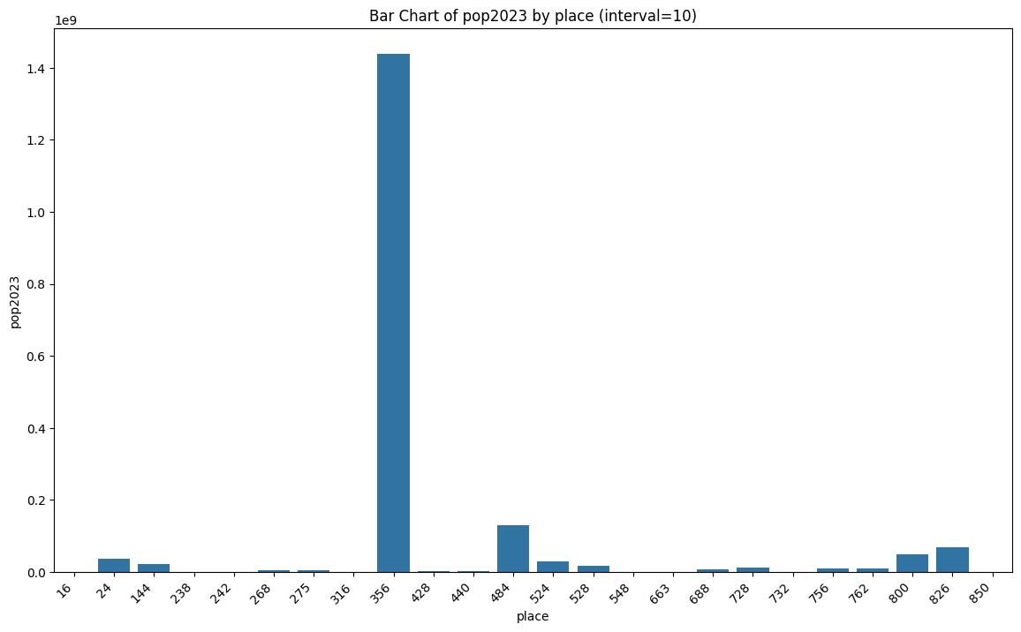

*Figure 1Bar Chart.*

This chart highlights the uneven distribution of population across countries

**2. Scatter Plot: Population Growth from 1980 to 2023**

Next, I plotted population in 1980 against population in 2023 to see if there was a growth pattern.

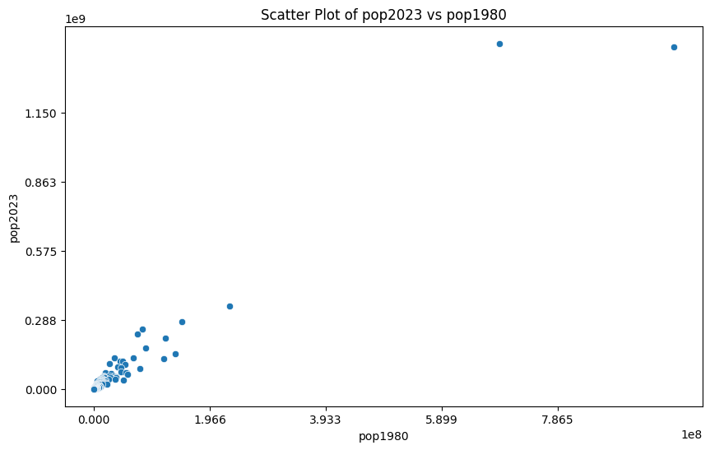

*Figure 2Scatter Plot.*

**3. Correlation Matrix Heatmap**

The correlation heatmap shows how different metrics are related.

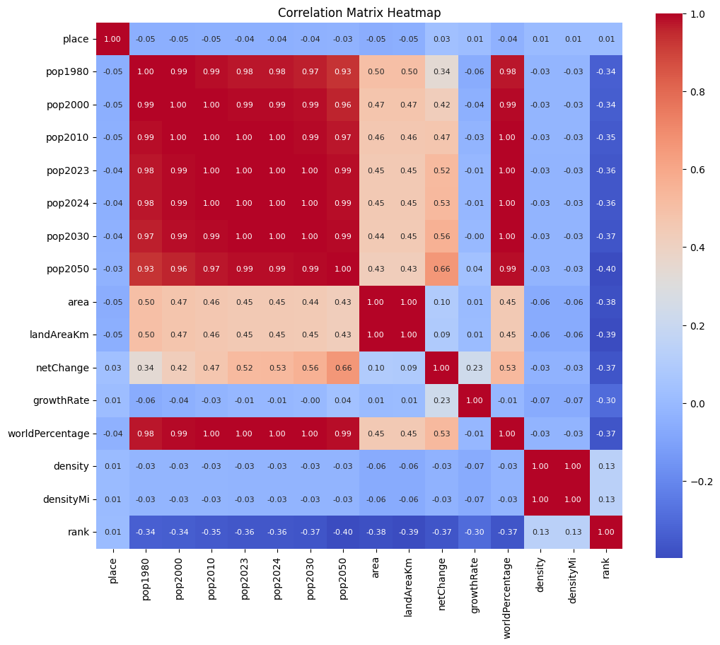

**Conclusion**

This analysis of global population data highlights several interesting trends. The bar chart and scatter plot show that populations have grown over time but are distributed unevenly across countries. The correlation heatmap helps identify relationships between factors like land area and population. Together, these visualizations reveal that while population growth is common worldwide, the rate and scale of growth can differ significantly.